📄 Types of DNS Queries
# Source: AI Source: Provided by: [Data Path: Persons Table -> ID Column: 1, Name_En Column: Motasem Essam] -> From: [ChatGPT] on [1/18/2026]
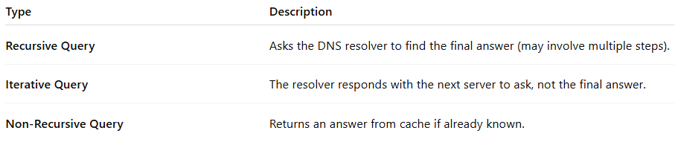

Type | Description
Recursive Query | Asks the DNS resolver to find the final answer (may involve multiple steps).
Iterative Query | The resolver responds with the next server to ask, not the final answer.
Non-Recursive Query | Returns an answer from cache if already known.

